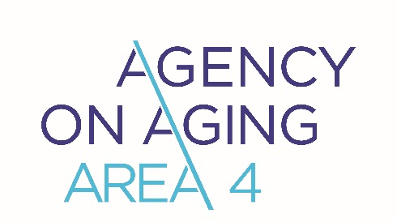

Public Comment Form

Members of the public who wish to provide input through the public hearing process without attending a meeting may do so by completing this form.

Your Name (optional): Phone:

Group you represent (if any): E-mail:

What county do you live in? Date:

Please write your comments in the space below.

Please submit your completed form to: smartinez@agencyonaging4.org
This form must be received by AAA4 no later than: April 8, 2026

Serving Nevada, Placer, Sacramento, Sierra, Sutter, Yolo &Yuba Counties

1401 El Camino Ave., #400 / Sacramento, CA 95815 / Phone: (916) 486-1876 / Website: www.agencyonaging4.org

